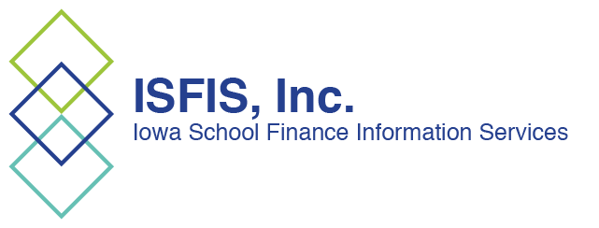
ISFIS, Inc.
1201 63rd Street
Des Moines, IA 50311
(515) 251-5970
www.iowaschoolfinance.com

ISFIS Tax Policy/Tax Cuts Analysis for School Leaders April 20, 2018

PK-12 Funding is currently equal to about 42% of the state general fund. If there is a billion-dollar reduction in state general fund revenues, public schools proportional share of that is $420 million. Rhetoric is swirling around various tax reform proposals and their impact as negotiations to close down the 2018 Legislative Session are in the works. This ISFIS analysis will hopefully provide school leaders with the 20,000-foot view necessary to weigh in with legislators and the public as you see fit, with some reasoned information and background.

Comparisons are tough during high level negotiations because positions may change any of a number of things based on compromises made since original legislation was considered in committees (or on the Senate floor). Legislative leaders, Sen. Whitver and Rep. Upmeyer, are quoted in the April 18 Des Moines Register, Deal may be near on state tax cuts at Iowa Capitol, as being close to an agreement.

Big Issues in Tax Policy on the table:
The Governor and House and Senate leaders are working towards consensus on three proposals SSB 3195 Governor’s bill, HF 2489 House proposal, and SF 2383 Senate proposal. Although some things are included in all three proposals, such as expansion of the 529 savings plans to include K-12 private school tuition, several key tax policy ideas are under consideration in the differences between the chambers and the Governor, which include:
- How much to cut?
  - Governor cuts $1.7 billion by 2023
  - House cuts $1.3 billion by 2023
  - Senate round 2 cuts over $2 billion in five years
  - Be wary of big numbers and check the annual anticipated impact in the LSA fiscal notes. Some of the numbers claimed are cumulative, making it more difficult to realize the impact on any given year’s revenue and budgeting impact. Tables from the fiscal notes are included below.
- Should corporate tax cuts be part of it?
  - House and Governor say no, suggesting they wait until later
  - Senate lowers the corporate income tax rate from 12% to 7% (it is already really much lower than 12% due to federal deductibility)
- Should Iowa eliminate federal deductibility?
  - Federal deductibility means that the taxes Iowans pay to the federal government are deducted from their income which is then taxed by the state. This makes comparison of tax rates with other states misleading, since only 3 states have this provision. Elimination of federal deductibility without a corresponding reduction in the state income tax rate would increase income taxes on high earners.
  - Estimated impact is $575 million annually according to Department of Revenue
  - House doesn’t, Governor does, Senate doesn’t
- Will tax cuts of this magnitude grow the economy enough to be revenue neutral to the state? Regarding the proposed corporate income tax reduction in the Senate proposal, if there is an Iowa corporation whose sales are roughly $100,000, completely within Iowa, they would pay 12%. To recover a 5% reduction in their rate, they would need to generate an additional 71% in net income to make it revenue neutral to the state. This is unlikely on a tax savings of $5,000 per year.

- Should plan include economic triggers/safeguards? Governor’s proposal includes economic triggers. They have been considered in various forms of the House and Senate proposals, too. It’s doubtful enough economic growth will occur to offset a very large revenue reduction, or sufficient extra revenue growth will occur to provide adequate increases for education or fund new educational policy priorities. Tax cuts typically will not have a sufficient impact on the economy to offset the loss in general fund revenue to the state, which is why some states use economic growth triggers when phasing in tax cuts. The triggers provide one way to hold the system accountable but also provide a backstop to avoid further tax cuts beyond the first year of impact.
- Expansion of the tax base? Should the tax reform policy increase other revenues, such as modernizing the sales tax base, in order to offset some of the proposed income tax reduction? Various versions of the proposals apply state sales taxes or other taxes to things currently not taxes, such as credit unions, online retail sales, information services or even Uber.
  - Senate taxes credit unions, House does not.
  - They are at odds on online sales – but expect to see something in the mix so there is the ability to generate some funds to offset the otherwise big income tax reductions.

Looking at fiscal impact: SSB 3195 Governor’s Proposal, HF 2489 House Proposal, and SF 2383 Senate Proposal. The best unbiased place to look for impact is in the nonpartisan budget staff's write up of fiscal notes.

There is no fiscal note for the Governor's proposal, because a bill has to clear a committee before the LSA staff writes a fiscal note. Here's the link to the Governor’s bill, SSB 3195

SF 2383 Senate proposal has a much bigger bottom line impact on State general fund revenues. Here's the link to this fiscal note https://www.legis.iowa.gov/docs/publications/FN/948145.pdf from which this table is copied. The Senate version goes much further on individual income tax reductions, cuts the corporate income tax and does not offset much of the income tax reductions with any sales tax modernization.

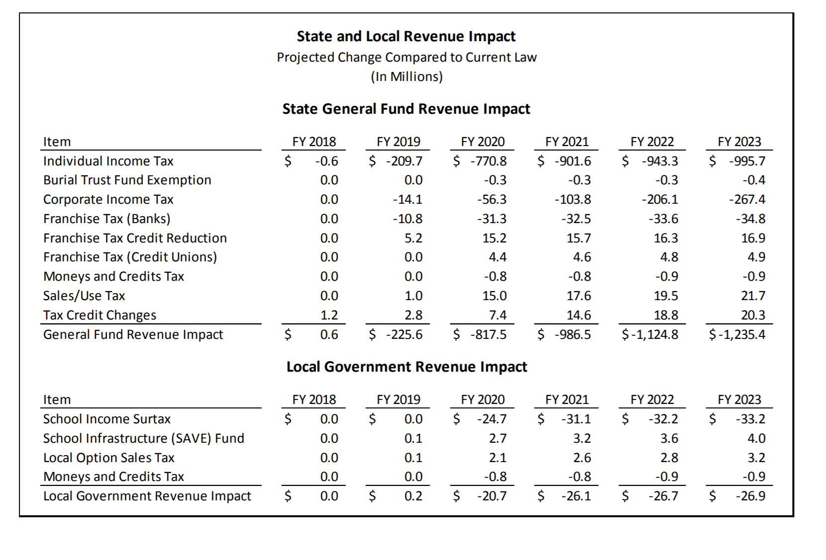
HF 2489 House proposal fiscal note is linked here: https://www.legis.iowa.gov/docs/publications/FN/962756.pdf
The general fund and local government revenue impact table below shows annual reductions, which for the state general fund never tops $300 million a year, but through 2023 combines to over $1.2 million. That's part of the issue with the rhetoric in both directions, claiming the biggest tax cut ever or the biggest gutting of the state revenue stream ever, is that they add up multiple years of impact and express it as one number. But even on an annualized basis, it is significant and will make it more difficult to find any money for ongoing educational funding let alone new policies of importance. For FY 2019, it's $99 million and for FY 2020, its $269 million, which exceeds the total new revenues the state has experienced annually for a couple of years. Expect more deappropriations unless the economy grows. The House proposal does propose expanding the sales tax base, which offsets part of the income tax reduction, but does not eliminate it. Here's the table:

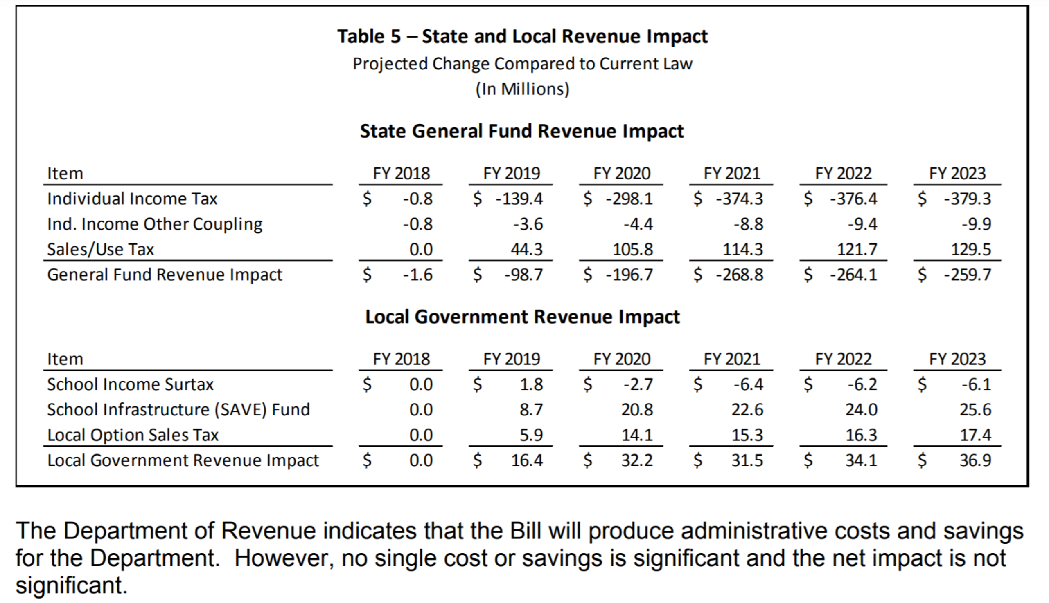

Conclusion
In summary, the health and condition of state General Fund revenues are important to school districts and tax reforms should carefully consider the impact on the economy and the ability of the legislature to fund Iowa’s priorities, including public education.

Margaret Buckton
Lobbyist, Partner
ISFIS, Inc.
1201 63rd St.
Des Moines, IA 50311
Office: (515) 251-5970
Cell: (515) 201-3755
margaret@iowaschoolfinance.com

Larry Sigel
Partner
ISFIS, Inc.
1201 63rd St.
Des Moines, IA 50311
Office: (515) 251-5970
Cell: (515) 490-9951
larry@iowaschoolfinance.com

