IowaWrites

Welcome to the IowaWrites newsletter. These resources are intended to support your team as you help students build their writing expertise with WriteToLearn!

News

Starting next year, writing will be assessed on the state test. Below is Senate File 240 passed and signed into law by Governor Branstad during the 2017 Legislative Session. Following is the relevant section:
“The department of education shall issue a request for proposals for the selection of a statewide assessment of student progress to be administered in the school year beginning July 1, 2018, and each succeeding school year. The assessment shall measure individual student growth and be aligned to the Iowa core academic standards for grades three through eight and at least one high school grade. The assessment shall be capable of measuring student performance in English language arts, including reading and writing; mathematics; and science.”
If you are interested in reading the entire bill, it can be found here. https://www.legis.iowa.gov/docs/publications/LGE/87/SF240.pdf

The Iowa Department of Education and the State Board of Education are in the process of implementing a new state assessment, with an award of proposal made to the American Institutes of Research. We will follow the progress of regulations and test development as it unfolds and keep you informed of developments relevant to your work in the area of student writing.

We at ISFIS know WriteToLearn can help provide intensive practice for students in writing as well as support for reading achievement through the use of well written essay prompts and reading selections students will be asked to summarize. As in basketball and the piano, practice makes perfect, and WriteToLearn can help.

Focus on the Overview Report in WriteToLearn

Reports in WriteToLearn are designed to help educators know in which areas students need more instruction. Students write, then WriteToLearn analyzes that writing, aligning it to the 6-Traits or College and Career Ready standards. Next WTL provides feedback to students, as well as feedback to teachers informing the lesson planning process and next instructional efforts.

The formal name of the report featured this month is the Overview Report, but we like to refer to it as the “Gradebook Report.” In this case, student performance for a 7th grade essay prompt called Description of a Remarkable Place, aligned to the 6-Traits of Writing, is the focus of the report. The data you see below from fictitious students, illustrates the details of this valuable report. Red indicates far below proficient. Orange represents approaching proficient. Green represents proficient. This report has a million wonderful features, among them:
- Individual Student Writing Performance: If you look at a student name and move your eyes horizontally, you will see a student’s overall performance, as well as performance on each of the 6-Traits. Additionally, note information about how many words the student has written, spelling and grammatical errors, the percent of repeated information, the minutes on task, how many drafts students have submitted (attempts), and how many of the drafts were passing (passing attempts).
- Individual Student Trait Mastery: If you look at the overall score or a trait and move your eyes vertically, you will see how each student did on that trait or element. This look provides instructional information related to who needs immediate individual intervention, who might benefit from some small group instruction in one of the traits, or if there are any traits where whole group instruction is in order. It will also reveal if there are students who require additional challenge or if an entire class is ready to move on to the next level.

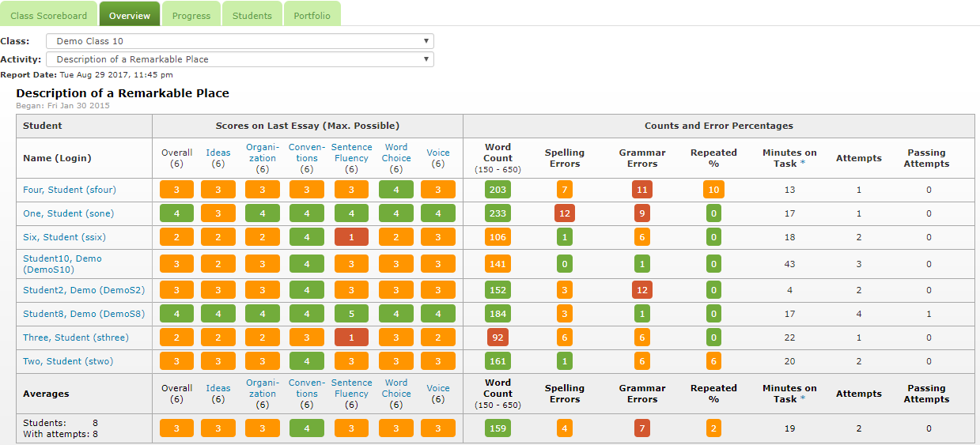

Notice on the report right below the second column heading, Scores on Last Essay, that there is information on student performance in each trait. If the teacher looks vertically, s/he will notice that only one student is proficient in the trait of ideas, suggesting students need more instruction in this particular trait. Since so many students aren’t passing this trait, this would be a good focus for a whole class lesson. If the teacher clicks on the Ideas link, tons of information will come up about the concept of Ideas that can help in planning lessons, including information about the Main Idea, Supporting Ideas, and Supporting Details. Also notice the Tips for Different Types of Writing, as well as Essay Examples that show examples of an essay that scores one on the 6 Traits rubric in ideas, as well as essays that score 2, 3, 4, 5, and 6. Some teachers print the essay draft from this link that scored poorly in Ideas, one that scored mid-range, and one that scored well. Teachers then share all three with students and ask them to determine which essay scored well and why. They ask them to identify the differences from the other two in the trait of Details. Students can work individually or in small groups with a rubric and determine those important differences to inform their own writing.

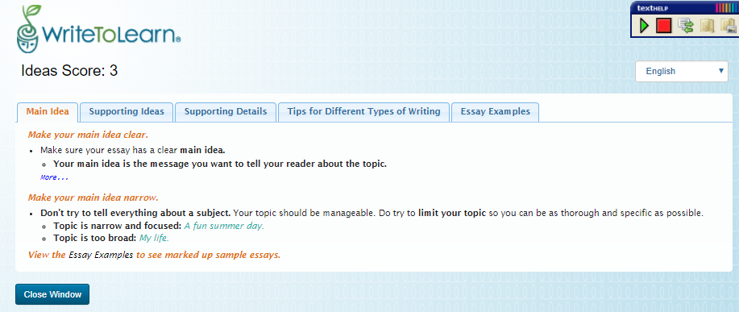

Leadership

One thing the leadership team can do to support implementation is to establish implementation goals and track them. It is easy to track implementation in the administrative account, and Susie would be glad to send you instructions or host a GotoMeeting with the principal or leadership team related to how that is done.
When you set goals, remember that what teachers do will impact what students accomplish. Also, as you establish goals, teachers must collaborate, particularly at the middle and high school levels, so students have a reasonable amount of writing to tackle. If every teacher assigns a summary and an essay, students may have 6 or 8 summaries and 6 or 8 essays monthly to complete. Most will soon tire of writing! However, if the ELA and history or science teacher collaborate on an essay, the ELA teacher can focus on the elements of writing and the history or science teacher can focus on the content. The history or science teacher not working on the month’s essay can assign a summary to be completed. Also, looking at reports in collaborative team meetings will provide direction in planning lessons.

We have seen many goals established at schools, but here are a couple that seem particularly useful.
- Students will complete at least one essay and one summary activity monthly.
- Students will complete at least one essay and one summary activity quarterly.

Writing Instruction

As with all content, if we want students to learn to write well, we have to teach them to do so. A quick scan of the research in reading instruction reveals several effective practices:

- Have students read well-written text, including a variety of text structures. Also, reading well written text to students aloud, no matter the age, and then pointing out what the writer did to engage the reader is an effective practice. Read the example below.

The teacher asks students to bring up the two paragraphs she’s going to read aloud to them, which she posted in Google Classroom. She reminds them, “Writers often set up the reader to understand key elements of what’s coming in the book or essay in the first paragraph or two – sometimes even the first sentence. I’m going to read to you the first two paragraphs in the Doris Kearns Goodwin’s biography of Abraham Lincoln entitled, Team of Rivals. This book was made into a movie you might have seen called Lincoln. When we’re finished, I want you to jot down what you learned in the first two paragraphs that might give you an idea of what we’re going to learn in Ms. Goodwin’s biography of Abraham Lincoln.

On May 18, 1860, the day when the Republican Party would nominate its candidate for president, Abraham Lincoln was up early. As he climbed the stairs to his plainly furnished law office on the south side of the public square in Springfield, Illinois, breakfast was being served at the 130-room Chenery House on Fourth Street. Fresh butter, flour, lard, and eggs were being put out for sale at the City Grocery Store on North Sixth Street. And in the morning newspaper, the proprietors at Smith, Wickersham & Company had announced the arrival of a large spring stock of silks, calicos, ginghams, and linens, along with a new supply of the latest styles of hosiery and gloves.

The Republicans had chosen to meet in Chicago. A new convention hall called the “Wigwam” had been constructed for the occasion. The first ballot was not due to be called until 10 a.m. and Lincoln, although patient by nature, was visibly “nervous, fidgety, and intensely excited.” With an outside chance to secure the Republican nomination for the highest office of the land, he was unable to focus on his work. Even under ordinary circumstances, many would have found concentration difficult in the untidy office Lincoln shared with his younger partner, William Herndon. Two worktables, piled high with papers and correspondence, formed a T in the center of the room. Additional documents and letters spilled out from the drawers and pigeonholes of an outmoded secretary in the corner. When he needed a particular piece of correspondence, Lincoln had to rifle through disorderly stacks of paper, rummaging, as a last resort, in the lining of his old plug hat, where he often put stray letters and notes.

The teacher reminds the students of what she wants them to write and gives them a few minutes to jot down some ideas related to how these paragraphs might set up the reader to know what’s coming in the book. Then she says, “When I read the first part of the second sentence, ‘As he climbed the stairs to his plainly furnished law office on the south side of the public square in Springfield, Illinois…’ I thought a couple of things. By saying that the office was plainly furnished, it seemed to me that Ms. Goodwin was going to root her story in the idea that Abraham Lincoln was a man of modest means. Also, I know that Springfield, Missouri, isn’t a huge city, so it appears Presidents can come from anywhere. I know that Mr. Lincoln became President and that he led the U.S. through the Civil War, which are both grand accomplishments. It sounds to me like Ms. Goodwin might focus her book on how this guy who wasn’t rich and famous and was from a medium sized, Midwestern city was going to change the world. A Margaret Meade quote states, "Never doubt that a small group of thoughtful, committed citizens can change the world. Indeed, it is the only thing that ever has.” I thought maybe that premise was the basis of Doris Kearns Goodwin’s work. I know as I read the book, I will look for evidence of my interpretation of her introduction.” (Notice the teacher models before she asks students to share their ideas. That way they are clear about what she expects. If students repeat what the teacher said, they are most likely learning the process and that’s what we want them to do!)

The teacher then says, “What were your predictions about what the book will be about?” Kids share their ideas with a partner and then share out to the group, reading the text that sparked their thinking and sharing what they thought would come after reading or hearing Kearns Goodwin’s introductory paragraphs. Teachers collects their ideas and shares them on the white board. The class will be reading this non-fiction book in American History. She tells them they will come back to their predictions periodically to see if what they expected to happen is happening.

Finally, the teacher notes, “Now I would like you to find a book or essay in our library or at home or on the Internet that leads with a compelling introduction that you think predicts what will be in the book or essay. “Be ready to share the introduction and what you think it tells you the book will reveal to you, the reader,” she says.

- Teacher modeling of writing while thinking out-loud about the process they want students to learn: For example, this is what the teacher might say. “As I write the opening sentences of this essay, I want the reader to think, ‘Wow – the promise this writing offers is interesting, and I want to keep reading.’ That idea drives my thinking about what I want that first sentence or paragraph to convey. If I’m going to write about the population decline in rural Iowa, not exactly a compelling subject for all readers, I need to write something that will grab them. In the farm crisis in the 1980s there was a saying, ‘Would the last person out of rural Iowa turn out the lights?’ That saying clarified for me what was happening in my town – people were leaving for other jobs, other opportunities. They were my friends and I was watching them go and felt the sea change that was happening in rural Iowa. If I’m going to talk about the population decline, I think I should paint a contrast between what Smallville was when I moved here several decades ago and what it’s like now. I should help them visualize the difference. I might start my essay something like this. ‘When I first moved to Smallville, there were clothing stores, a couple of grocery businesses, a huge hardware store, shoe shops, a dry cleaners, a dry goods establishment, several bars and restaurants, an old fashioned dime store with interesting treasures, and many other thriving businesses on the town square and just off of it. Cars and people on the square were abundant, driving, stopping to visit on the Courthouse Square, going into the restaurants for lunch.’ I think this shows that the business area was thriving – states there were many businesses and a lot of people. Now I want to contrast with how it and many Iowa small towns look today. Today in Smallville, you will find a couple of attorneys’ offices, empty buildings, and one restored opera house that offers promise. That picture is not unlike many small Iowa towns I drive through. There are only a few vehicles and it seems like all roads lead out of town.’ This sentence paints a picture of desolation – not the vibrant places small towns in Iowa were decades ago. Now I need to share what I hope will be the future, so the reader will get the idea this piece is going to be about the past, the present, and the future. ‘I don’t think it has to be that way. I think we can stop that out migration and make Smallville and other Iowa towns places where many people want to live, work, and raise their families, but that will take local investment and public policy changes. There is work to do by all of us.’ Overall, I think this short paragraph paints a picture of the past and the present and makes it clear what I’m going to write about - small towns were once vibrant centers of commerce, they aren’t anymore, and we can do something about it. Share your thoughts with the person next to you about what you learned from my model and then we’ll have a whole class discussion.”

- Expect students to write daily engaging in a variety of writing tasks

- Provide feedback to students related to their writing

Resources

The What Works Clearing House provides two practice guides for writing, Teaching Elementary School Students to Be Effective Writers and Teaching Secondary Students to Write Effectively. Below is a quick overview of each publication, but the guides themselves are rich with instructional information.

Teaching Elementary School Students to Be Effective Writers , Elementary Practice Guide
- Provide daily time for students to write.
- Teach students to use the writing process for a variety of purposes.
- Teach students to become fluent with handwriting, spelling, sentence construction, typing, and word processing.
- Create an engaged community of writers.
,
Teaching Secondary Students to Write Effectively, Secondary Practice Guide
- Explicitly teach appropriate writing strategies using a Model-Practice-Reflect instructional cycle.
- Integrate writing and reading to emphasize key writing features.
- Use assessments of student writing to inform instruction and feedback.

The Iowa Department of Education provides this website: Teaching the Iowa Core Writing Standards

The Oregon Department of Education also provides excellent resources: K-12 Writing Instruction

MORE Resources

Facebook Page: https://www.facebook.com/EducatorResources/
Twitter Feed: @IowaWrite
Find out more about WriteToLearn on our Iowa School Finance websites:
- http://iowaschoolfinance.com/WritetoLearn
- http://iowaschoolfinance.com/write_to_learn_user_resources
Technical Assistance: Please call or email Susie (susie@iowaschoolfinance.com) or 641-745-5284. Email is preferred, since she is often in schools during the day.

Quotes

“You must write every single day of your life... You must lurk in libraries and climb the stacks like ladders to sniff books like perfumes and wear books like hats upon your crazy heads... may you be in love every day for the next 20,000 days. And out of that love, remake a world.”
― Ray Bradbury

“Write what should not be forgotten.”
― Isabel Allende

“What an astonishing thing a book is. It's a flat object made from a tree with flexible parts on which are imprinted lots of funny dark squiggles. But one glance at it and you're inside the mind of another person, maybe somebody dead for thousands of years. Across the millennia, an author is speaking clearly and silently inside your head, directly to you. Writing is perhaps the greatest of human inventions, binding together people who never knew each other, citizens of distant epochs. Books break the shackles of time. A book is proof that humans are capable of working magic."
[Cosmos, Part 11: The Persistence of Memory (1980)]”
― Carl Sagan, Cosmos

