**Why Are Some of**

**Iowa’s Students Worth Less?**

**Decades of Unequal Funding Ability:**

Since the 1970s the Iowa Legislature and Governor have set a limit on how much schools can spend every year on each student. The cap is set by a complex formula, called the School Foundation Formula, which starts with a base of local property taxes. By adding state funding on top of local tax revenues the combined amount was supposed to look similar between school districts to prevent wealthier communities from creating an unfair advantage for their students over less prosperous communities. From the beginning, the 1970s the formula included permission for any districts spending more than the cap to stay at the higher spending by using more local property tax revenue. This difference has been in place for the last 45 years and, despite minimal changes, remains today. Now in 2016 the difference is $175 per student from the highest funded districts to the lowest funded districts, those held to the cap set by the state.

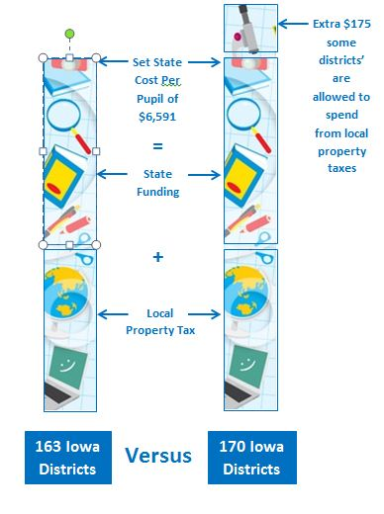****

**Local Impact:**

Currently, 170 of Iowa’s school districts are able to spend more than other districts, as much as $175 per student. The other 163 Iowa school districts are capped at spending even if they have funds available in their bank account. Though $175 a year may not seem like a lot, in a district as big as Davenport that is $2.8 million every year that should be going into classrooms that isn’t allowed to be spent, even though the district has the funding in reserves. Imagine how much money that is over 45 years and what that money could have provided to students. Across the state this inequality means that some school districts are allowed to spend more on their students than other districts.

**What would these extra funds mean for your school and for your students?**

Ironically, this inequality is most likely to impact the highest need schools, as the original gap was impacted by local property tax values. Education leaders in the state have analyzed the districts that are held to the cap and compared a variety of demographic factors to those districts allowed to spend more on each student. These correlation studies show that districts with the state’s lowest property values, the highest ethnic minority population and higher rates of disabilities, special education, and ELL learners, are more likely to be under the cap.

The ultimate impact of these missing funds is on student success. The same analysis shows a correlation between this reduced funding and achievement among the state’s neediest students. Districts held to the state cap have students more likely to experience:

* Higher elementary class size and higher guidance counselor case loads
* Lower scores in math as students reach the upper elementary grades
* Lower graduation rates, with students less likely to attend a 4-year university

**Legislative Solutions:**

The cost to the state of fixing this inequality is close to $73.5 million. Finance experts at the state, the Legislative Services Agency, have costed out the various proposals, including a more affordable phased-in approach. Another option, if a phased-in approach is taken, is to allow districts with money in the bank to spend it up to the $175 difference per student in the short term. Many districts have these “cash reserves” statewide, totaling over $689 million, that could be spent on students until the state finds a solution, if the state would allow it. Davenport is in such a situation with $25 million in reserves without permission of the state to access it. Though controversial, local property taxes could also play a role in the solution. For the 170 school districts above the $6,591 per pupil, a state solution would actually create local property tax relief as the funds would now come from a state level source.

For more information, visit the Iowa School Finance Information Services toolkit at <http://www.isfis.net/node/55> or the Funding Equality Now Facebook page.